Cairo University – Faculty of Engineering
Computer Engineering Department • CMPN451
Data Mining, Big Data and Analytics • Spring 2021

Lab 6
Linear Regression

Submitted by
Rufaida Muhammad Sayed Ahmed
ID: 9202550
Rawan Ahmed Fouad
ID: 9220302
Eng. Omar Samir

Part 1 – Synthetic Linear Data

Q1. How do data points change for different values of standard deviation?
The standard deviation (sd) controls the amount of noise added to the linear model y = 5 + 6x + ε, where ε ~ N(0, sd²).
- Small sd (e.g., 0.5): Data points cluster very tightly around the regression line — the linear relationship is clearly visible.
- Default sd (2): Moderate scatter around the line — the trend is still clear but with visible spread.
- Large sd (e.g., 10): Points are widely scattered and the linear relationship becomes hard to see visually.
- Very large sd (e.g., 100): Points are completely random-looking with no visible trend at all — the noise completely overwhelms the signal.
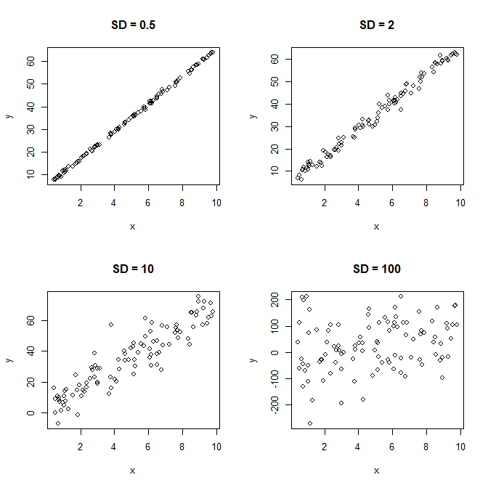
Q2. How are the coefficients affected by changing the standard deviation?
The true model has intercept = 5 and slope = 6. Changing sd affects how close the estimated coefficients are to these true values:
- Small sd → Estimated coefficients stay very close to the true values (5 and 6) because there is little noise.
- Large sd → Coefficients deviate more from the true values because the noise dominates the signal.
- Very large sd (e.g., 100) → Coefficients become very unreliable and can differ dramatically from the true values (5 and 6), since the noise completely dominates.
In all cases, the coefficients will be approximately correct on average — but their variance increases with sd.
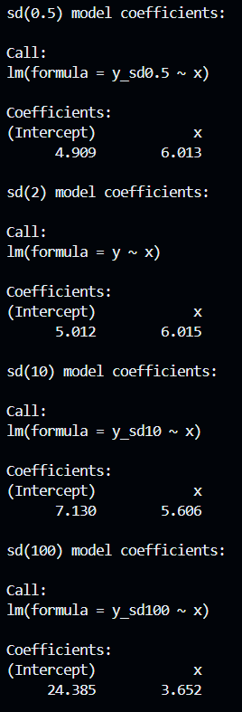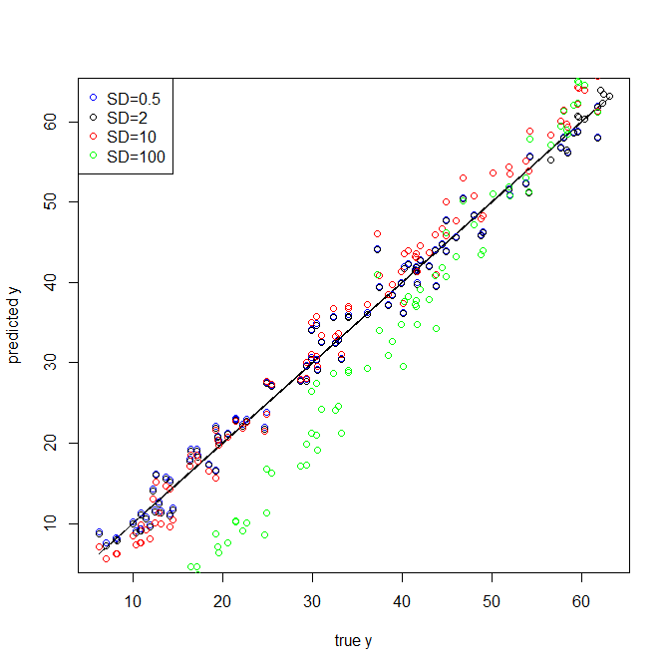

Q3. How is R-squared affected by changing the standard deviation?
- Small sd → R-squared is close to 1.0, meaning the model explains almost all the variance in y.
- Large sd → R-squared drops down in the 0 direction, because the noise makes it hard for x to explain the variance in y.
- Very large sd (e.g., 100) → R-squared approaches 0 or may even be essentially 0, as the noise completely overwhelms any relationship between x and y.
R-squared measures the proportion of variance in y explained by x. More noise = less explained variance = lower R-squared.
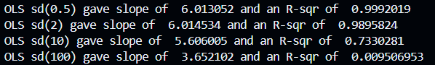

Q4. What do you conclude about the residual plot? Is it a good residual plot?
Yes, this is a good residual plot. The residuals are randomly scattered around the horizontal zero line with no visible pattern or curve, and the variance appears roughly constant across all fitted values (homoscedasticity). This confirms that the linear model is appropriate for this data.
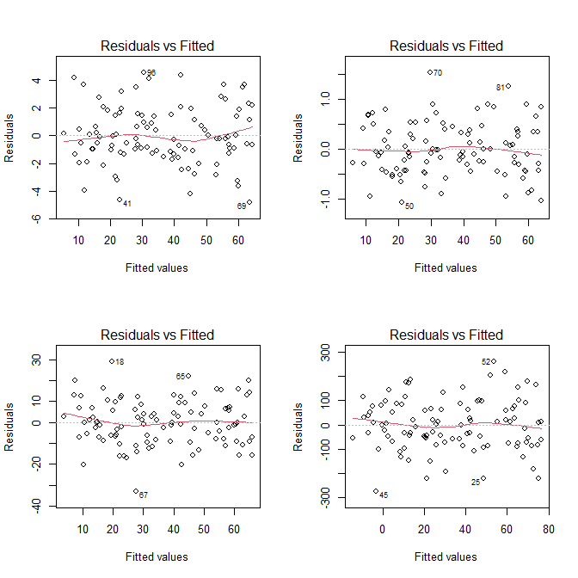

Part 2 – Nonlinear Data with Linear Model

Q5. What do you conclude about the residual plot? Is it a good residual plot?
Yes, this is still a good residual plot. The nonlinear coefficient (0.1) in the model y = 5 + 6x + 0.1x² + ε is very small, so the nonlinearity is negligible. The residuals appear randomly scattered with no discernible pattern, and the linear model remains a good approximation in this case.
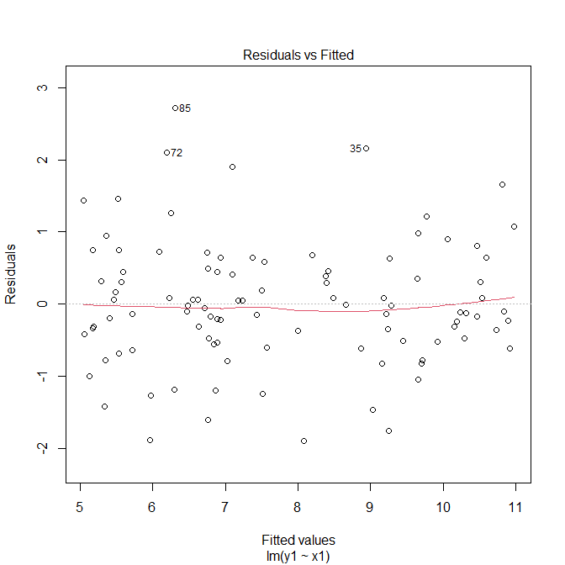

Q6. Change the nonlinear coefficient to a large value. What do you notice?
When the nonlinear coefficient is set to a large value (e.g., 50), so that the model becomes y = 5 + 6x + 50x² + ε:
- The residual plot shows a clear curved (U-shaped or inverted U-shaped) pattern.
- Residuals are NOT randomly scattered — they are systematically positive in some regions and negative in others.
- This is a bad residual plot. It indicates that the linear model is no longer adequate for this data.
Conclusion: When nonlinearity is strong, a polynomial or nonlinear model should be used instead of a simple linear regression.
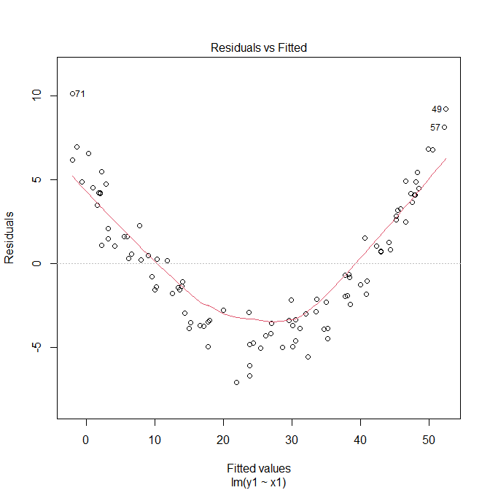

Part 3 – Lung Capacity Dataset

Q7. Import the dataset. What are the variables?
Q8. Scatter plot of Age (x-axis) vs LungCap (y-axis)
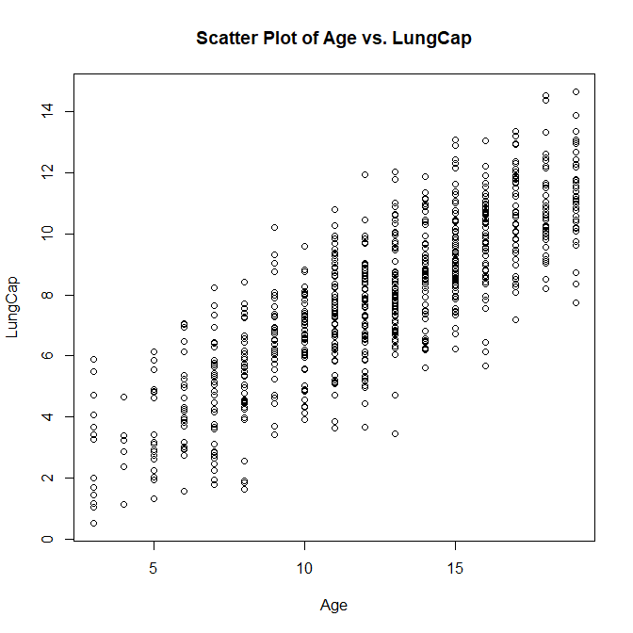

Q9. Pairwise scatter plot between LungCap, Age, and Height
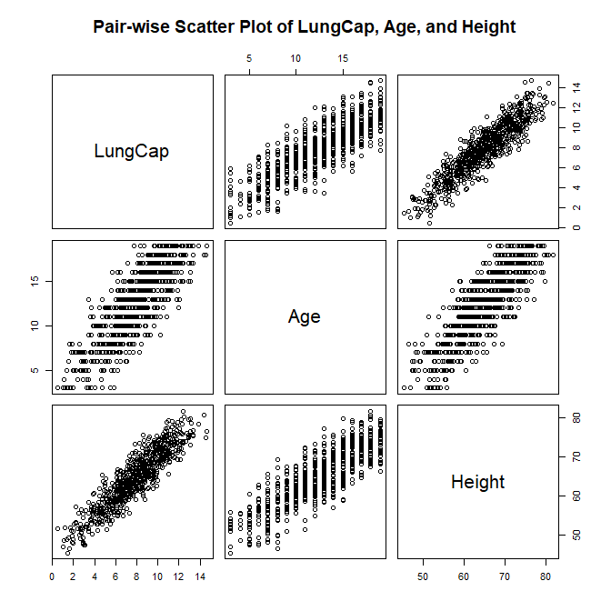

Q10. Correlation between Age & LungCap, and Height & LungCap
Q11. Which variable is more correlated to LungCap?
Height is more correlated to LungCap (r = 0.9122) than Age (r = 0.8197). Both are strongly correlated, but Height has a slightly higher correlation coefficient.

Q12. Are Height and LungCap correlated? Why?
Yes, Height and LungCap are strongly positively correlated (r = 0.9122).
This makes biological sense: taller people have larger chest cavities, which physically allows for greater lung capacity. As height increases, the lungs have more space to expand, resulting in higher lung capacity.

Q13. Fit a linear regression model with LungCap as dependent and all other variables as independent
model <- lm(LungCap ~ ., data=data)
# The dot (.) means: use ALL other columns as independent variables
# i.e., Age + Height + Smoke + Gender + Caesarean

Q14. Show a summary of the model
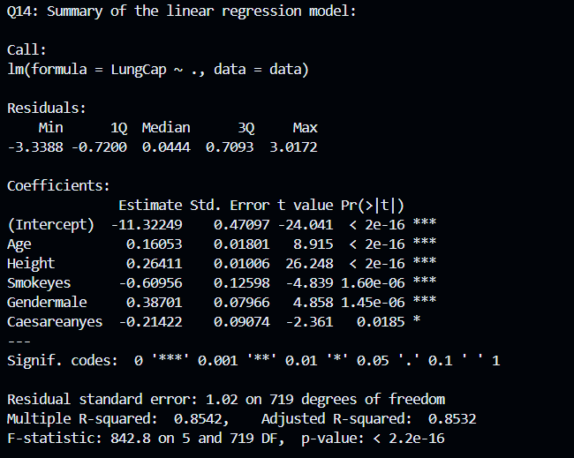
Q15. What is the R-squared value? What does it indicate?

This means the model explains approximately 85.4% of the variance in LungCap using the five independent variables. R-squared is a measure of goodness of fit — a value closer to 1 means the model fits the data better. 0.8542 indicates a strong model fit.

Q16. Show the coefficients. Do they make sense?
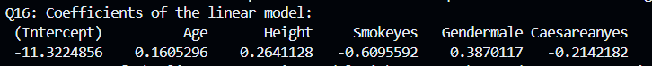Interpretation of each coefficient:
- Intercept (-11.3225): The intercept of -11.3225 means that when all independent variables are zero (Age = 0, Height = 0, non-smoker, female, non-Caesarean), the predicted LungCap would be -11.3225. This is physically impossible since lung capacity can't be negative, which means the intercept doesn't make real-world sense on its own. This is actually very common in regression — the intercept is a mathematical necessity to fit the line, but it only has a meaningful interpretation if having all variables equal to zero is realistic, which it isn't here (no one has Height = 0 or Age = 0).
- Age (+0.1605): Makes sense — older individuals tend to have higher lung capacity.
- Height (+0.2641): Makes sense — taller people have larger lungs.
- Smoke (-0.6096): Makes sense — smoking reduces lung capacity.
- Gender (+0.3870): Makes sense — males generally have higher lung capacity than females.
- Caesarean (-0.2142): Questionable. It is not immediately obvious why being born via C-section would reduce lung capacity. This variable may not be meaningful and should be investigated further.
What to do about the questionable variable: Check its p-value for statistical significance, consult domain knowledge or literature, and consider removing it if it is not significant and has no biological justification.

Q17. Redraw scatter plot of Age vs LungCap and overlay the regression line
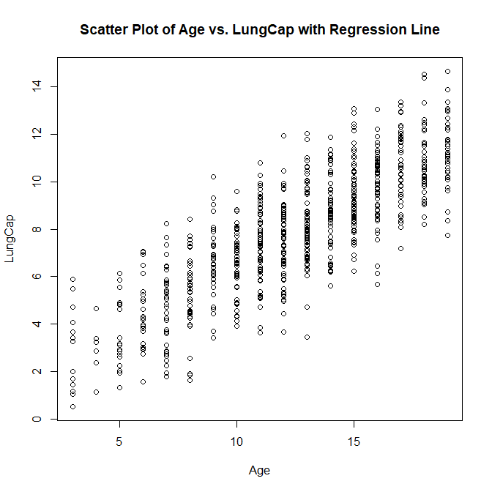Why is the line NOT displayed on the plot?
abline() only uses the first two coefficients of the model: the intercept and the coefficient of Age. However, this model has 5 predictors. The line is drawn assuming all other variables are zero, which places it outside the visible range of the plot. To properly overlay a line, a simple model with Age as the only predictor should be used.

Q18. New model using only Age, Smoke, and Caesarean
Summary for the new model:
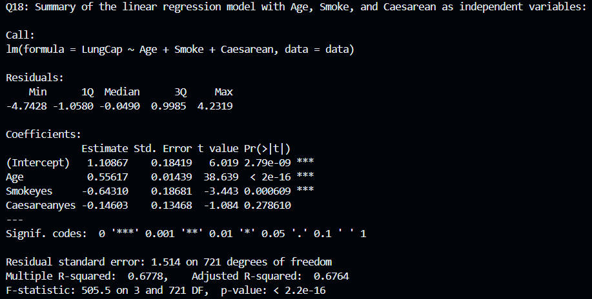

Q19. Coefficients and scatter plot for Model 2
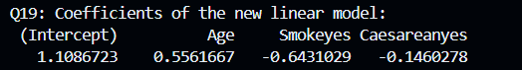
Do they make sense?
- Intercept (+1.1087): More reasonable than Model 1's intercept, but still not fully meaningful since Age = 0 is unrealistic.
- Age (+0.5562): Makes sense — lung capacity increases with age.
- Smoke (-0.6431): Makes sense — smoking reduces lung capacity.
- Caesarean (-0.1460): Still questionable for the same reasons as before.
What happened compared to Model 1?
The coefficient of Age jumped from 0.1605 to 0.5562 when Height was removed. This is because Age and Height are correlated — when Height is absent from the model, Age absorbs its explanatory power. This is a classic effect of omitted variable bias / multicollinearity. The R-squared also dropped from 0.8542 to 0.6778, showing the model is now less accurate.

For the scatter plot with the regression line from Model 2:
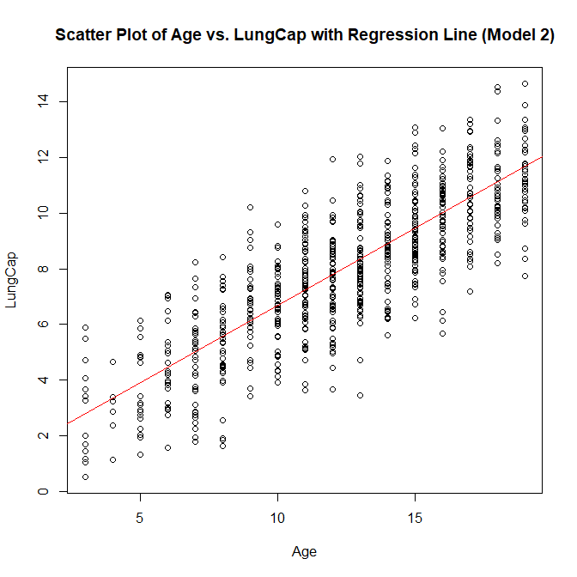Now the line IS visible because Age is the first predictor and the model is simpler as we have removed the variables are correlated with other variables and that doesn't make sense. The line shows a positive slope — as Age increases, LungCap increases.

Q20. Predict results on training data
#(Q20)Predict results for this regression line on the training data.
ypred2 <- predict(model2)

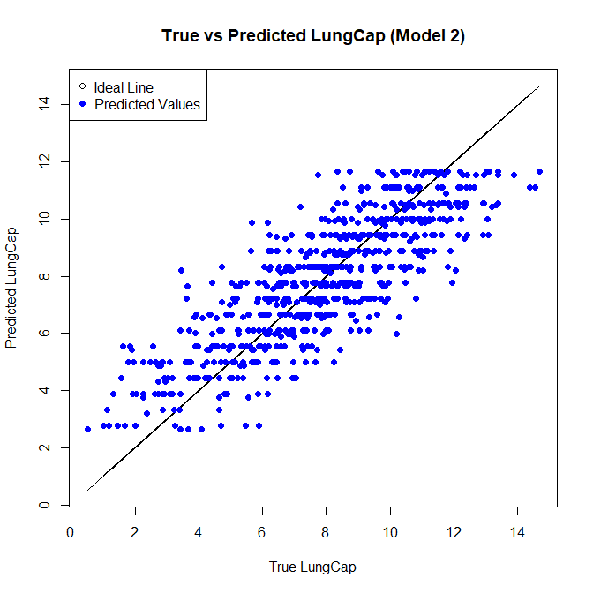

Q21. Calculate the Mean Squared Error (MSE) of the training data
mse <- mean((data$LungCap - ypred2)^2)
This means the model's predictions are off by an average of √2.28 ≈ 1.51 units of LungCap. Given that LungCap ranges from approximately 1 to 15 in this dataset, this is a reasonable training error for the simpler 3-variable model, but it could be improved by including more relevant predictors such as Height.

